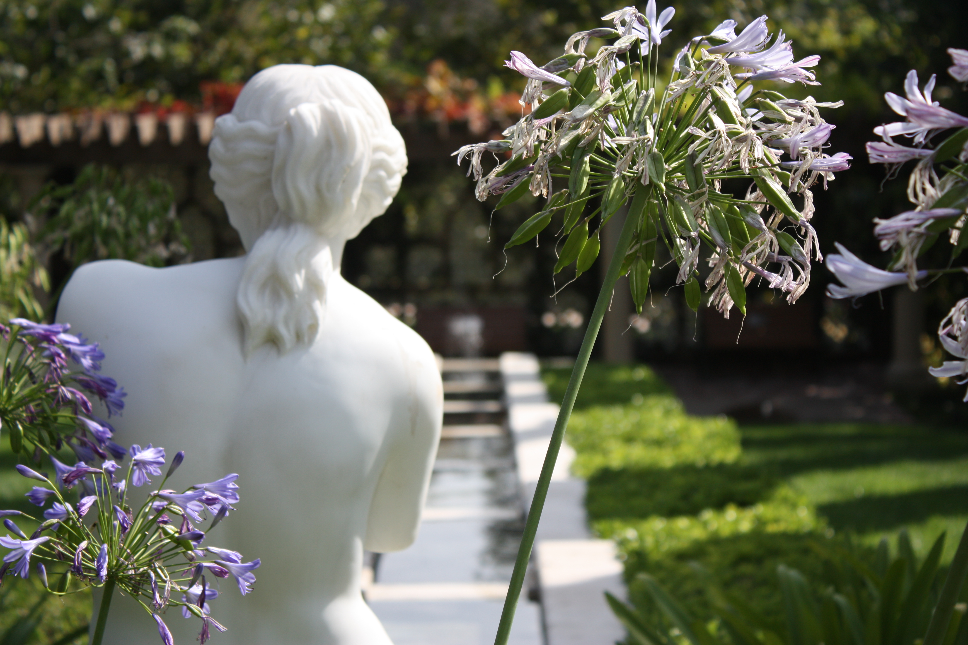

## R O B E R T G I L L E N

✹

A PLAY

BURIED LIES

✹